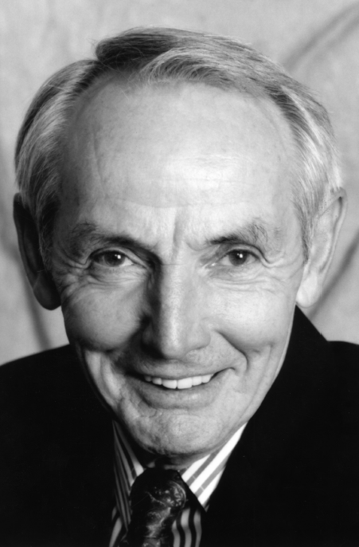
John Gregory Campbell
February 21, 1933 – March 19, 2016

John Gregory Campbell passed away Saturday, March 19, 2016, unexpectedly from complications of lung disease. He went peacefully, surrounded by his loving family.

Born in Presque Isle, Maine on February 21, 1933, to William Francis and Ida Bell Shaw Campbell, John was the second born of seven children. They were potato farmers which rooted his work ethic, and their Catholic faith shaped his values and was a guiding force his entire life. He served four years in the United States Air Force and tended to the electronics on B-52 bombers. He was the Eastern Air Force Welterweight Boxing Champion, trained by Sarge Johnson who also trained the 1972 US Olympic Boxing Team and Sugar Ray Leonard. He attended college at the University of Maine, Orono where he studied Electrical Engineering.

He met the love of his life, Loretta Johnston while she attended Fisher College in Boston. They married and shared 54 years together. Their four children were his precious jewels. His grandchildren infused a joy and renewed energy in his life. He was so proud of each of them for their very special qualities.

John was a sales and marketing executive working with a variety of established companies and an entrepreneur with many start-ups in the developmental years of the video electronics industry. He instilled a fierce work ethic in his family and colleagues that was uncompromised.

John was strong, loyal, witty, kind, loving, compassionate and a defender of the underdog.

His younger years were filled with sailing and barefoot waterskiing, yet he never took the time to learn to swim. He was a tenacious tennis player and golfer.

The impact John had on so many will keep him alive in our hearts and memories. Stories about him will continue to bring smiles to all.

He is survived by his wife, Loretta Johnston Campbell; children Leslie Campbell Michael (Jim), Michele Campbell Morgan (Mike), Bill Campbell (Holly), Greg Campbell (Tatiane); grandchildren Gregory, John Robert, Spencer and Sophia Campbell; brothers, Peter, Charles and Thomas Campbell. He is preceded in death by his parents, William and Ida Campbell; siblings Wilma Footer, Cecelia Mary McQuinn and Herbert Campbell.

Funeral Mass will be held at St. Cecilia Catholic Church, 1301 Sycamore Avenue, Tustin, California at 2:30 PM, Wednesday, March 30, 2016. A Rosary will precede the Mass at 1:30 PM.

